UG2023

PPO-based Internships at Ashoka? 2
Marquee Internship Opportunities for UG2023 2
What is a PPO? 2
Who is Eligible? 2
How to Begin? 2
What is CPP? 3
Career Prep Program (CPP): 3 Mandatory Components: 4
Step 1: Update Superset profile & Send verification request via Duperset 4
Step 2: Enroll to Expert Resume Session by 20th July 4
1. Post-verification, enroll in dummy internship cycle 4
2. Post enrolling in dummy cycle, apply for Resume Review: Mandatory Step (Set 1) 5
3. Post applying for Resume Review: Mandatory Step (Set 1), Sign up for Expert Slot 5
Once you apply for resume review on Superset, you’ll receive access to a Google Sheet containing time slots with external experts. These are professionals you can meet with to review and refine your resume. 5
Missed Sessions Policy 5
Post-Session Feedback 5
Step 3: Sign-Up for Expert Interview Session 6
Important Note About Verification: 6
Career Prep Program (CPP): Non-Mandatory Components 7
Group Sessions with CDO 7
One-on-One Sessions with CDO Experts 7
CPP Calendar & Non-Mandatory Session Schedule 7
Steps for Marquee Internships? 8
1. Resume Preparation 8
Resume Building Resources 8
A. Resume Repository 8
B. Master & Variant Resume Templates 8
C. PlaceCom Resume Prompt Sheet 8
D. Office Hours with PlaceCom 8
2. Profile Verification on Superset 9
3. Application to Companies 9
4. Shortlisting and Multiple Rounds 9
Interview Preparation Resources 9
A. Interview Preparation Sheet 9
B. Mentor-Mentee Program 9
Frequently Asked Questions (FAQs) 10

PPO-based Internships at Ashoka?

Marquee Internship Opportunities for UG2023
This year, top-tier companies are expected to visit Ashoka University to hire interns for Summer 2026 — and these aren't just any internships. Many of them come with the potential for a PPO (Pre-Placement Offer), meaning that if you perform well during your internship, you could receive a full-time job offer before you even graduate!
We are hoping to host marquee firms such as McKinsey & Company, BCG, Bain, and others.

What is a PPO?
A Pre-Placement Offer (PPO) is a full-time job offer extended to a student before the final placement season, based on their performance during a summer internship. It is a fast-track route to securing a job early, often from the same company where the internship was completed.

Who is Eligible?
These internship opportunities are exclusively for:
- 3rd Year Undergraduate students (UG 2023)
Since these roles are closely tied to the final placement process, the Placement Committee (PlaceCom), along with AIC (Internship Cell), will oversee the recruitment process for these students.
Note: AIC continues to manage internships for 1st and 2nd year UG students fully. However, for PPO-track internships, PlaceCom shall be involved along with AIC.
This guide will give you a brief overview of the process and expectations for these PPO-driven internships.

How to Begin?
The first step towards getting a Marquee, PPO based internship is to be prepared! That’s why we have a Career Prep Program (CPP)!

What is CPP?
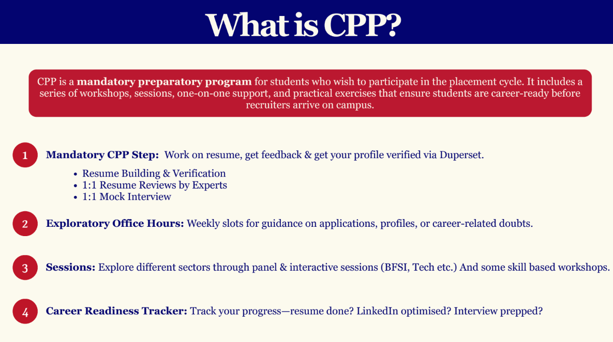

As outlined above, there are 3 mandatory steps in the Career Prep Program (CPP) — completing these is essential to be eligible for internship opportunities in your 3rd year.
You can find the detailed checklist of these mandatory steps in the next section.
In addition to these, there are also several non-mandatory but highly recommended steps, which are listed in the following sections. These are designed to enhance your preparation and maximize your chances of success.

Career Prep Program (CPP): 3 Mandatory Components:

Step 1: Update Superset profile & Send verification request via Duperset
Follow the Superset Verifications Guide: PlaceCom_Superset Verification Guidelines

- Make sure you do all edits to your profile and follow the basic resume guidelines.
- Make sure your passout batch is 2027 on Superset.
- The verification process for UG 2023 students has been handled jointly by the PlaceCom and AIC teams. PoCs have been divided between the two teams, and you can find the allocation of students here.
- If you have any verification-related requests or queries, please make sure to email both PlaceCom and AIC in the same email thread to ensure a smooth and timely response.

Step 2: Enroll to Expert Resume Session by 20th July
Enrolling to Expert resume session also has 3 steps further:-

Post-verification, enroll in dummy internship cycle
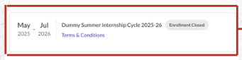
Log into your account → go to ‘My Profile’ → ‘Basic Details’ → scroll down and you will see ‘Enrollments’ → Click on the enroll button located on the right side of ‘Dummy Internship Cycle 2025-26’.

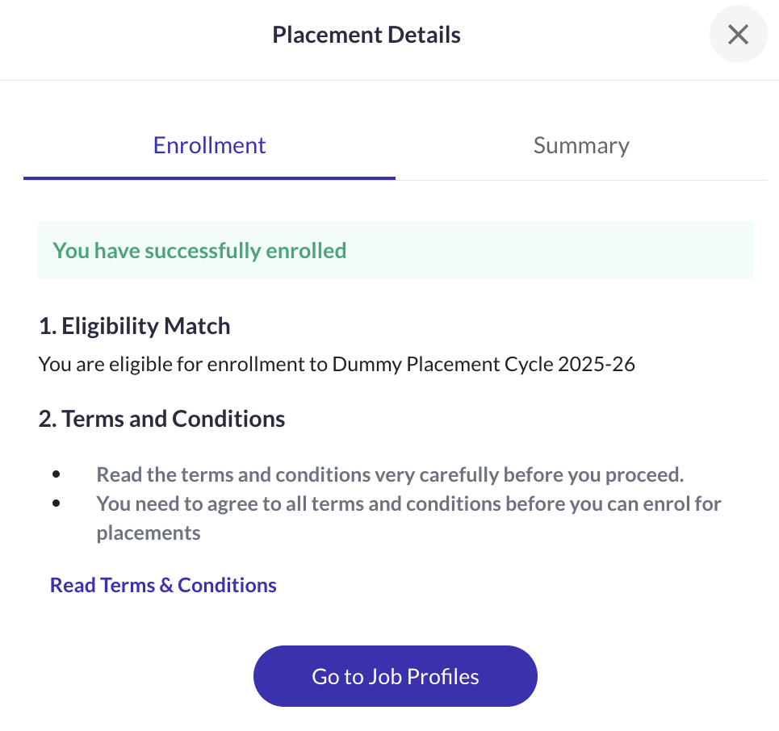
Once you enroll, you will see screen as shown below:

Internship Cycle

Post enrolling in dummy cycle, apply for Resume Review: Mandatory Step (Set 1)
Log into your account → go to ‘Job Profiles’ → ‘Basic Details’ → click on ‘Resume Review: Mandatory Step [Set 1]’ → Click on ‘Apply’ that is on the top right corner of the ‘Resume Review: Mandatory Step [Set 1]’ Job Profile.

Post applying for Resume Review: Mandatory Step (Set 1/2), Sign up for Expert Slot
Once you apply for resume review on Superset, you’ll receive access to a Google Sheet on your email containing time slots with external experts. These are professionals you can meet with to review and refine your resume.

Weekly Expert Sessions
- Expert resume sessions will be conducted on weekends.
- The sign-up sheet for each weekend opens every Wednesday at 4:00 PM of the previous week and closes by Thursday EOD of the previous week.
  - For example, slots for 16th & 17th August will open on 6th August (Wednesday) and close on 7th August (Thursday).

Redlined Resume Feedback (Before Your Session)
- After applying on Superset, you’ll receive a redlined version of your resume (with comments and suggestions from your assigned expert) on your email. This may happen even before you sign up for a specific time slot.
- This redlined resume is based on the resume you submitted while applying on Superset in Step 2.2.

Before the Session: Submit an Updated Resume
You are expected to revise your resume based on the redline comments. Then, go back to the sign-up sheet you received and:
- Upload your updated resume (PDF) to your Ashoka Google Drive.
- Ensure access is granted to:
  - priyanka.laishram@mbatrek.com
  - connect.cdo@ashoka.edu.in
  - connect.placecom@ashoka.edu.in
- Paste the updated resume link in the 'Resume Submission' column of the same sign-up sheet.
  - The updated resume must be generated via Superset → Resume Builder.
  - No re-verification is needed, just download the new version and upload it to Drive.
Deadline to submit the revised resume link: Wednesday EOD of the same week as your session.
(E.g., for 16th–17th August sessions, submit by 13th August)
Session Day
- You will receive a reminder email 2–3 hours before your session.
- Please ensure you attend the session on time using the credentials provided.

Missed Sessions Policy
If you miss your scheduled session or fail to show up:
- Your ID will be blocked for 2 weeks
- You will not be allowed to book any resume review sessions during this period

Post-Session Feedback
After your expert session, you’ll receive a feedback form. Kindly fill it out; it helps us improve future sessions and offerings.
Guidelines to Fill the Expert Resume Sign-up Sheet

COLUMN | What to Fill | Notes
F (MANDATORY)  IMP: Used for sending session reminders. | Your Name (Name Chip) | Click on the name smart chip, start typing your name (your Ashoka email should pop up).  Do not manually type your name or email ID.
G (MANDATORY) | Batch | This will be auto-filled once the name chip is selected correctly.
H (MANDATORY) | Phone Numbers | Required for quick communication.
I (MANDATORY) | Major | Enter your declared major.
J (Suggested) | Student Expectations | Share any specific areas you want feedback on (e.g., formatting, content, role/sector specific etc.).
O  (IMP MANDATORY) | Latest Resume | Upload your latest resume to your Ashoka Google Drive  Please ensure that you give the PDF files access to @priyanka.laishram@mbatrek.com, connect.cdo@ashoka.edu.in & connect.placecom@ashoka.edu.in

Step 3: Sign-Up for Expert Interview Session
Once the resume reviews are complete, you will get a sign-up google sheet for an expert interview session. Once you complete that, all mandatory steps for CPP are completed.

Student Tracker
  - You can also see if you have enrolled by finding your name on this sheet. Use this sheet to track your individual progress across all mandatory steps for the CPP (Career Preparation Programme):CPP Student Tracker_2025-26.

*Please note: This tracker gets updated every Sunday EOD, after all weekly expert resume sessions conclude.

Important Note About Verification:
If you wish to enroll for the Dummy Cycle and Expert Resume Session scheduled on 20th July, please ensure that you submit your profile for verification by 18th July.
This does not mean you can’t update your profile or get it verified later — you absolutely can. However, in order to enroll, your profile must be submitted and verified at least once before the deadline. You can make changes and re-verify it afterward if needed.

Career Prep Program (CPP): Non-Mandatory Components
While CPP has 3 mandatory steps, there are also several non-mandatory but highly recommended components designed to support your preparation further.

Group Sessions with CDO
- Held every Friday at 6:30 PM
- Conducted by CDO experts on various placement prep topics
- All sessions are recorded and accessible via this folder: CPP Session Recordings-Pre Day 0
- Strongly recommended to watch all recordings — they provide valuable preparation insights!

One-on-One Sessions with CDO Experts
If you'd like personalized guidance, you can also schedule 1-on-1 sessions with CDO experts.
How to Book a Slot:
- Log in to AMS
- Go to Student Support → Advising Hub: Office Hours
- From the drop-down, choose Career Prep Program
- Select a date and time that works for you
- Your slot will be auto-added to your calendar
A few quick notes:
- These Office Hours are distinct from the Career Development Program and Postgraduate Office sessions on AMS
- They are not part of the mandatory resume review or mock interviews required for placement enrollment.
- Attendance is not mandatory—but highly encouraged!

CPP Calendar & Non-Mandatory Session Schedule
To view the full CPP calendar, including upcoming group sessions and other events, check this link: CPP Calendar_2025-26.xlsx

Steps for Marquee Internships?

1. Resume Preparation
Before applying to any company, you must create a tailored resume. Use the resources below to guide your process:

Resume Building Resources
Kickstart your placement prep with these essential resources to help you craft an impactful resume. These tools will help you understand formatting and content and how to tailor your resume to different roles and industries.

Resume Repository
- Explore resumes of previously placed students across sectors like consulting, finance, social impact, and more. Use these as reference points while crafting your own resume.
- Link to Resume Repository: PlaceCom_Resume Repository

Master & Variant Resume Templates
- Use these to structure your own résumé according to the CDO guidelines.
Includes:
- Master Resume Template: General template used across sectors
- Variant Resume Examples: Sample customizations for different job profiles
- Link to the Template: PlaceCom_Master VS Variant Resume Making.pdf

PlaceCom Resume Prompt Sheet
- A guided worksheet to help you brainstorm and articulate your achievements, responsibilities, and impact across internships, projects, and leadership roles.
- Link to the prompt sheet: PlaceCom_Prompt Sheet

Office Hours with PlaceCom
- Book a 15-minute one-on-one slot with a PlaceCom member to get feedback on your draft before submitting to expert sessions.
- Link for booking a session: PlaceCom_Office Hours

2. Profile Verification on Superset
Once your resume is ready, submit it and get your profile verified via Duperset.

3. Application to Companies
Apply to company-specific job profiles using the variant resume tailored for that role on Superset by submitting your resume & other details required.

4. Shortlisting and Multiple Rounds
If shortlisted:
- You may be invited for technical tests, aptitude rounds, or interviews (this varies by company).
- Some rounds might be online, monitored, or timed submissions.
- These preliminary rounds.

Interview Preparation Resources
Prepare confidently for your interviews with curated, insider-led resources. These tools feature real questions asked by recruiters and tips shared by selected students to help you build confidence and clarity.

Interview Preparation Sheet
  - Contains actual interview questions asked by recruiters from companies such as BCG, Accenture, Deloitte, DE Shaw, TCF, etc. A great resource to understand what recruiters look for and tailor your prep accordingly.
  - Link to Interview Prep Sheet: PlaceCom_Interview Preparation Sheet'25

Mentor-Mentee Program
  - Navigating academics and career choices can be challenging—but you don’t have to do it alone.
  - This initiative pairs current students with recent Ashoka alumni working at top firms like BCG, EY, Deloitte, Dalberg, and more. We will be offering one-on-one mentorship to help you explore career options, seek advice on placements/internships, and gain professional insights.
  - Link to Mentor-Mentee Program sign-up sheet: Application Form. This is phase 1 of the program, we will be having multiple phases with more mentors soon!

Frequently Asked Questions (FAQs)

Q: Can I make changes to my profile after it has been verified?
A: Yes, you can make changes. However, you must send a new verification request each time you update your profile.

Q: How do I send a verification request again (2nd time or more)?
A: Use Duperset every time you need to send a verification request.

Q: What is Duperset?
A: Duperset is a tool developed by the PlaceCom Projects team to streamline and manage the profile verification process efficiently. Check it out here

Q: How long does profile verification take?
A: It typically takes up to 48 hours for your profile to be verified by your Point of Contact (PoC).

Q: Can I book another resume slot with an expert to improve my resume further?
A: Yes, but only after everyone in your set has completed their first session. We prioritize students who haven’t had a chance yet before allowing repeat slots.

Q: I missed enrolling in Set 1. What should I do?
A: Write to PlaceCom, AIC and CDO.

Q: I'm unable to apply for the dummy placement cycle. What could be the issue?
A: Please ensure the following:
- You are enrolled in the dummy cycle
- You are part of the Passout Batch 2027
- Your profile is verified on Superset
Q: I have verified my profile. Can I still add things to Superset later?
A:Yes. You can add more details like new internships, certifications, etc., even after verification. However, every new addition will require fresh verification with proper PDF proof.

Q: I’m not able to enrol in the Dummy Internship Cycle. What should I do?
A: Please follow these steps:

Step A: Ensure profile verification:
•⁠ ⁠Edit all details and attach PDF proof
• Using this, submit your profile for verification: How to get your profile verified.pdf
Submit request via [Duperset]: https://www.instagram.com/p/DLFhJ3SB_PX/?igsh=aHNvZjhuOGJyYThj
OR
⁠Submit request via [Website]: https://ashokaplacecom.github.io/verify.html

Step B: The education section must reflect:
•⁠ ⁠‘2027 Passout Batch’ under Batch
•⁠ ⁠Course End Date: May 2027
•⁠ ⁠(4 Year) written in the degree (only for UGs)

If not editable, post on the PlaceCom Chatroom with your enrolment ID and your issue.

Step C: Once the above are done, go to Basic Details on Superset and enroll in ‘Dummy Placement Cycle 2025-26’.

Q: My verification was approved, but it still shows pending. What should I do?
A: Resubmit the verification request via Duperset or the website. If it still doesn’t update after 48 hours, post on the PlaceCom Chatroom with your Enrollment ID.

Q: How do I get in touch with my PoC?
A: The PoC system is anonymous. You cannot contact them directly. Instead:
• Submit verification using Duperset or the website.
•⁠ ⁠If you need help, email toConnect Placecom or Internship Celldepending on who is your PoC.

Q: What proof is accepted for clubs and societies?
A: Any one of the following:
•⁠ Certificate or letter of appointment
•⁠ ⁠Screenshot of official email
•⁠ ⁠Screenshot from official club social media
•⁠ ⁠WhatsApp group screenshot (if created by official authority)

Upload as a PDF on Superset.

Q: I’m not receiving an OTP on the verification website. What should I do?
A: Try incognito mode or switch to the Duperset extension. If still unresolved, email Connect Placecom or post in the chatroom.

Q: Can third-year students (5th semester) sit for placements?
A: No. As per the updated policy, 5th-semester students in 4-year UG programmes cannot sit for placements. Email the CDO and cc Connect Placecomif you’d like to discuss.

Q: Where can I find the CPP session calendar?
A: Refer to this link: CPP Schedule 2025–26 → CPP Calendar_2025-26.xlsx

Q: What to do if my resume was wrongly rejected for personal pronouns?
A: Recheck for “I”, “my”, “we” and remove if missed. Then resubmit your one-page resume via Superset. Refer to the official PlaceCom_Resume Guidelines.pdffor clarity.

TIME TO SHINE TOGETHER ASHOKANS<3


Progress Tracker

Disclaimer

Hey guys, we know this was such a big task which all of you did beautifully! But we are sure that there were issues at times. So to make things smoother, please carefully review the next steps based on where you currently are in the enrollment process. Kindly follow the instructions relevant to your category:

Type 1: Completed till Expert Resume Session
(Profile got verified → Enrolled in Dummy Cycle → Applied for Expert Resume Session Set 1)
Next Steps:
- Book a resume review slot from the sheet that will be shared every Tuesday starting soon.
- Attend the slot and update your resume accordingly.
- (Optional) Attend an additional resume review if you want more feedback.
- (Mandatory) Attend the interview preparation slot – rollout will begin after resume slots.
- You’re all set!

Type 2: Only Enrolled in Dummy Cycle
(Profile got verified → Enrolled in Dummy Cycle)
Next Steps:
- Wait until the Resume Session Set 2 will open.
- Apply on Superset for Set 2 once announced.
- Book a resume review slot from the sheet shared every Tuesday from Mid-August.
- Attend the slot and update your resume accordingly.
- (Optional) Attend another resume review for further refinement.
- (Mandatory) Attend the interview preparation slot – rollout will begin after resume slots.
- You’re all set!

Type 3: Did Not Enroll in Dummy Cycle
If you did not enroll in the dummy cycle, please email us at connect.placecom@ashoka.edu.in explaining your situation. We’ll evaluate your case individually and guide you to move into Type 2.
You can refer to this video to learn how to check whether you're enrolled in the dummy cycle, Expert Resume Session Set 1, and other components.

